A
ccording to the Bureau of Labor Statistics there are close to 2 million people employed in the beverage manufacturing and distribution industry. As reported by OSHA, these workers are injured at a much higher rate than in other industry sectors. So much so that, in 2018, the Virginia Department of Labor and Industry issued a hazard alert warning for the potential dangers of unsafe materials handling and storage in the beverage distribution and retail industry.
Compared to private industry’s average days away from work related to overexertion (30.8 cases per 10,000 FTEs), beer/wine/and distilled alcoholic beverages wholesalers had a whopping 114.9 cases per 10,000 FTEs!
The question is - Why are over exertion injuries so prevalent in the beverage distribution industry?
Strains and sprains in the beverage distribution industry are primarily caused by heavy manual materials handling and highly repetitive motions that occur in awkward positions. All of these mechanisms of injury create musculoskeletal disorders (MSDs) involving everything from low back to upper limb disorders. Overexertion from lifting, pulling, and pushing heavy objects is one of the primary causes of these injuries. In addition, workers often have to perform these tasks in awkward and stressful postures, which contributes to increased sprains and strains. Taken alone, any one of these four factors creates injuries. Combined, they increase injuries exponentially.
Here’s why beverage distribution has high rates of injury
Awkward positions
High repetition
High demand
High forces

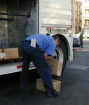
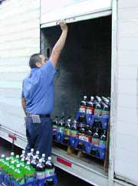
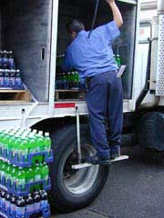
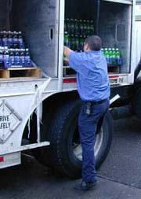
The most strenuous job tasks in beverage distribution:
High Lift Twist and Lift High Pulling Low Lift
Unloading cases, bottles or kegs of beverages from the truck. A case of bottled beer or soft drinks can weigh up to 42 pounds, an empty beer keg weighs 30 pounds, and a full keg weighs a whopping 160 pounds! And these weights are often handled above shoulder or below knee level, taking the worker out of the “golden zone” (shoulder to knee) for lifting. Often the lifting is accompanied by a twisting motion to get product out of the truck and onto the hand truck. And twisting with a load is a primary cause of low back dysfunction.

Wheeling a loaded hand truck to the point of delivery, specified by the customer, can be no easy feat – depending on access to the delivery site. Our job analyst has measured the following forces required to push and pull a hand truck/pallet jack:
  - 30-40 lbs. - Hand truck on a flat surface
  - 66-75 lbs. – Loaded manual pallet jack on a flat surface
  - 50-150 lbs. - Loaded hand truck up a ramp
  - 150-200 lbs. - Loaded hand truck up stairs
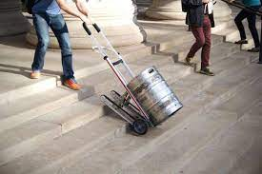
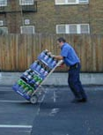
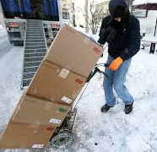
The exact force, of course, depends on the condition of the hand truck, how heavy it’s loaded, the steepness of the ramp and the height of each step. Regardless, these are extensive forces for the body to endure; day after day, week after week, month after month.

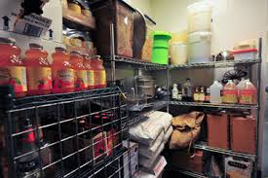
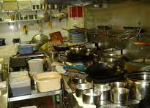
Manually unloading the hand truck and placing products on shelves/storage areas. Just think: reverse the process required to load the hand truck. And this time it may be into areas of confined space and even less ergonomically friendly than the truck.

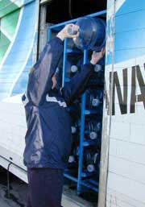
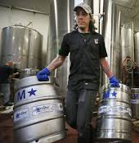
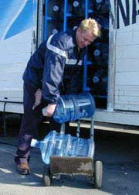
Retrieving empty returnable bottles/kegs. The weights may be less but are not insignificant and require similar awkward positions.

Take all of this force, repetition and awkward positions and add to it the stress of meeting a delivery deadline you have the perfect storm for additional injuries to occur. And when fellow associates are absent due to injury or illness, the deadlines become even more intense, the storm intensifies.. No wonder injury rates in the beverage distribution industry are off the charts!
So, why are these job tasks associated with injury?
Prolonged overhead reaching and above shoulder lifting
When the arms are raised up above shoulder height, the rotator cuff muscles are not at their strongest position and pressure is placed on the shoulder joint and the bursa (small fluid pad that protects the shoulder). Over time the wear and tear of that pressure can create a bursitis (inflammation of the bursa) or a tear in the rotator cuff muscles.

Prolonged bending or Low lift
When people spend prolonged time in a forward bent position or repetitively bend or lift below waist, the discs are squeezed, ligaments are stretched and the back muscles are stretched and have to work harder at the same time.
Anatomical Structure | Forward Bend/Low Lift
- Vertebrae | - Angle forward
- Discs | - Squeezed
- Ligaments | - Stretched
- Back Muscles | - Stretched & strained
Lift and Twist
Twisting with a load places a lot of stress on the discs of the spine. The outer fibers of the discs were made to support compressive forces – not twisting forces. If the discs sustain twisting forces over time, the fibers will weaken and the walls of the disc will allow the softer inner disc material to herniate.

Slips, trips and falls. BLS data shows that falls account for 15% of all fatalities, 25% of all non-fatal injuries, are associated with 95M lost work days, and are costing US employers $70 billion. And the problem isn’t decreasing. In fact, from 1998 to 2008 falls increased by 37% while all other work-related injuries increased by 6%.

In the beverage distribution industry, there are multiple factors that cause slips, trips and falls, slippery surfaces, caused by dirt, oil, grease; seasonal trip hazards like rain, snow and ice; use of ladders; changes in walkway levels and slopes; floor mats; debris and items dropped and left out in walkways; and, falls from working at heights. Busy warehouses floors become dirty – quickly. Dirt is bad news for multiple reasons in food and drink distribution industry, not the least of which is cross contamination.
And when a fall occurs, it is rarely benign. More likely the fall results in an injury: strain or sprain, head injury/concussion, cuts and abrasions or fracture.
Many believe that slips, trips and falls are inevitable. They assert that if you have slippery or uneven surfaces – which both delivery and warehouse associates encounter – you inevitably have falls and injuries.
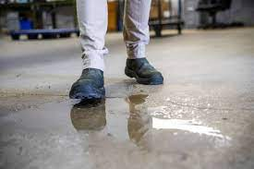
Certainly, these hazards pose a risk but do not guarantee an injury – especially if your associates have good balance. Contrary to popular belief, research shows that over 50% of what causes a fall if a worker encounters a fall hazard, depends on the person’s balance. If two people encounter a slippery or uneven surface – one with good balance, one with poor – the person with poor balance will be much more likely to fall and get injured.
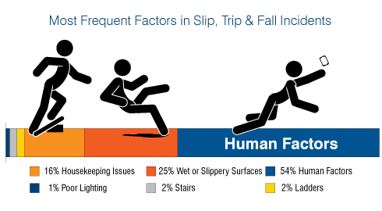

Internal (people) factors influencing falls. A myriad of factors can influence a person’s ability to stay upright when they encounter a slippery or uneven surface:
- Fatigue
- Health & physical status
- Aging
- Medication
- BMI
- Strength – especially in hips or ankle
- Reaction time
- Function of the vestibular (inner ear) system

If any one of these systems is not operating optimally, balance will be less than optimal and a fall will be more likely to happen. And, of course, a fall can result in a contusion, concussion, laceration, fracture or strain/sprain. The traditional approach to injury prevention and why it doesn’t work.
The traditional approach to managing these injuries is to conduct safety and ergonomic training. And while this training is important, no amount of training will prevent injuries if employees don’t have the basic physical ability to do the job. They can’t execute correct lifting technique if they don’t have the muscle power to do so. And when they inevitably encounter a slippery or uneven surface they’ll fall, even if they’re trained to watch for the hazard.
The Pre-Hire Physical Abilities Testing Alternative
Another alternative exists - Pre-Hire Physical Abilities Testing. Your talent acquisition team makes a conditional offer to the candidate who then goes to a nearby clinic for Physical Abilities Testing. Tests are tailored to each job and take approximately 30-45 minutes to administer. Candidates who pass are hired. For candidates who fail, the offer can be rescinded.
Beverage distribution is a high demand industry. Succeeding means that you need a workforce with the strength and stamina to handle the loads. With pre-hire Physical Abilities Testing, you can achieve the demands of beverage distribution while reducing injuries because you’re hiring people who are physically capable of performing your jobs.
Should you consider Pre-Hire Physical Abilities Testing?
Considering pre-hire Physical Abilities Testing for your organization makes sense if one or more of the following scenarios describes your situation:
- You’ve tried training and ergonomics and still have more injuries and OSHA recordables than you want.
- Your injuries and costs are trending upward.
- Lost and restricted duty days are affecting your productivity.
- Strains and sprains and slips, trips and falls comprise the majority of your non-fatal injuries.
- New hires often last only a few weeks or months because the job is too hard for them.
Like the idea of physical abilities testing, but not sure if it’s right for your organization? Whether or not we’re a fit, ErgoScience offers a free, no-obligation needs analysis.
Another topic that may interest you…
Case Study: Beverage distributor decreases work comp costs 50%
Receive our blog series on this topic.
Get more information.

https://www.osha.gov/etools/beverage-delivery

